DNS Server

🌐 What is a DNS Server (Domain Name System Server)?
# Source: Chatgpt (GPT-5-Mini) at [1/16/2026]
A DNS Server is a server that translates domain names (like example.com) into IP addresses (like 93.184.216.34) so computers can locate each other on the internet.
📌 Think of it as the "phonebook of the internet" — you type a name, it gives you a number (IP).

How DNS works photo
# Source: Data Path: Miscellaneous Folder -> Miscellaneous Database -> Miscellaneous Table -> ID: 30
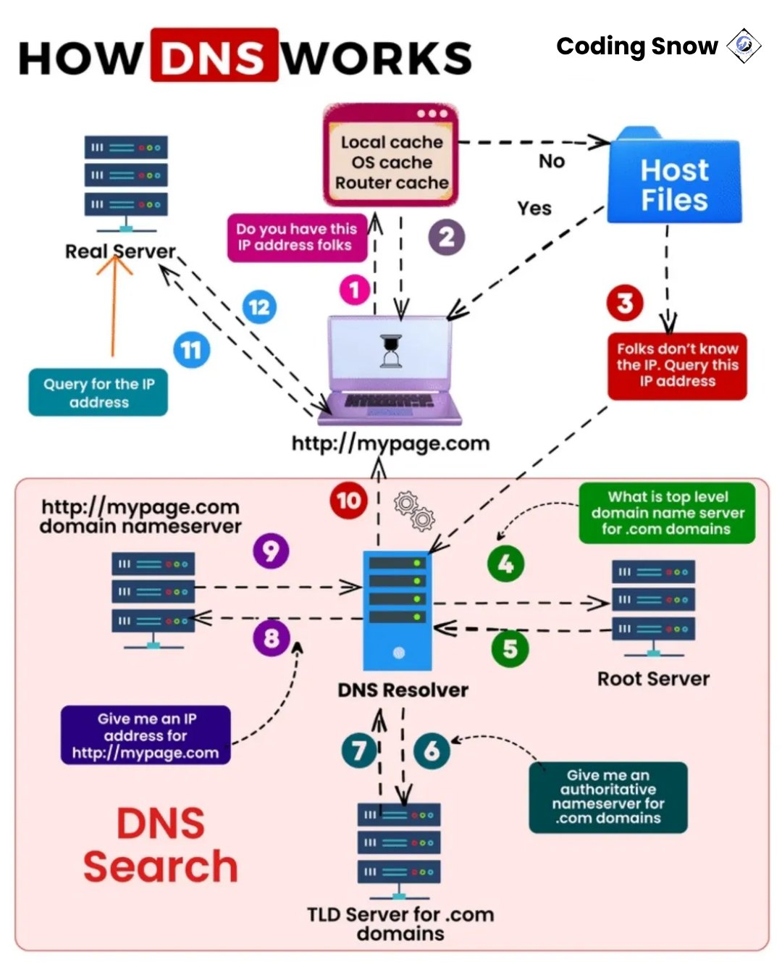

🧠 Simple Example
# Source: Chatgpt (GPT-5-Mini) at [1/16/2026]
When you visit:

https://www.google.com

Your computer doesn't know where google.com is — so it asks a DNS server, which replies with the correct IP address (e.g., 142.250.190.68). Now your browser can connect to the website.

🔄 What DNS Server Does
# Source: Chatgpt (GPT-5-Mini) at [1/16/2026]
Step | Description
1️⃣ | User types a domain in the browser
2️⃣ | Browser asks the DNS server to resolve it
3️⃣ | DNS server returns the IP address
4️⃣ | Browser connects to the IP and loads the site

🧩 Types of DNS Servers
# Source: Chatgpt (GPT-5-Mini) at [1/16/2026]
Type | Description
Recursive Resolver | The first server your device contacts; asks other servers
Root Server | Knows where the main TLD (.com, .net, etc.) servers are
TLD Server | Knows domains under a TLD (e.g., .com, .org)
Authoritative Server | The final answer; holds the actual domain-to-IP record

🎯 Why DNS is Important
# Source: Chatgpt (GPT-5-Mini) at [1/16/2026]
- ✅ Makes the internet human-friendly (you remember names, not IPs)
- ✅ Supports load balancing, mail routing, and domain security
- ✅ Crucial for web browsing, email, apps, etc.

🛡️ DNS & Security (Advanced)
# Source: Chatgpt (GPT-5-Mini) at [1/16/2026]
Feature | Purpose
DNSSEC | Secures DNS responses
DNS Filtering | Blocks malicious domains
DoH / DoT | Encrypt DNS requests
DNS Firewall | Prevents access to dangerous sites

✅ Summary
# Source: Chatgpt (GPT-5-Mini) at [1/16/2026]
Feature | Description
Full Name | Domain Name System Server
Purpose | Converts domain names to IP addresses
Users | Everyone using the internet
Important in | Browsing, email, mobile apps, IoT

Would you like to see a real-time example using tools like nslookup or how DNS caching works?

